YENEPOYA INSTITUTE OF ARTS, SCIENCE, COMMERCE AND MANAGEMENT
Project – Low Level Design (LLD)
on
End-to-End Encryption for Retail Cloud Apps

Student Name: Namruth V I
Register Number: 23BCCE123
Course: BCA in Cloud Computing, Cyber Security &
Ethical Hacking with IBM

Industry Mentor: | Mr. Shashank | Guided by: | Ms. Vijayalaxmi

S.No. | Section Title | Page No.
1 | Introduction | 1
1.1 | Purpose of the Document | 1
1.2 | Scope of the Document | 1
1.3 | System Overview | 1
2 | System Architecture | 2
2.1 | Detailed Application Architecture | 2
2.2 | Module Interaction Flow | 3
3 | Module Design | 4
3.1 | Module Overview | 4
3.2 | Authentication Module (Login/Register) | 4
3.3 | Encryption Module | 5
3.4 | Decryption Module | 5
3.5 | Messaging Module | 6
4 | Database Design | 7
4.1 | Database Schema | 7
4.2 | Table Structures | 7
4.3 | Relationships | 8
5 | API Design | 9
5.1 | API Endpoints | 9
5.2 | Request and Response Format | 10
6 | Process Flow | 11
6.1 | System Workflow | 11
7 | Session and Access Control | 13
8 | Error Handling and Validation | 14
9 | References | 15

1. Introduction
1.1 Purpose of the Document
This Low-Level Design (LLD) document provides a detailed technical blueprint for building the End-to-End Encryption for Retail Cloud Applications project.
The purpose of this document is to:
- Explain the internal working of each module
- Define how data flows between components
- Specify the database structure and API endpoints
- Guide developers to implement the system correctly

1.2 Scope of the Document
This document covers the complete technical design of the secure messaging system including system architecture, module design for login and encryption, database tables and relationships, API endpoints with request and response formats, process flows for key operations, session management, and error handling. The scope is limited to the encryption-based messaging system for retail environments and does not cover hardware or network infrastructure.
1.3 System Overview
The system is a web-based secure messaging application designed for retail environments where sensitive production data needs protection. When a sender types a message, the system encrypts it using the Fernet algorithm with a secret key before storing it in the database. When the receiver opens the message, the system decrypts it using the same key and displays the original message. Only the sender and receiver can read the message, ensuring end-to-end security. The system also supports role-based access with different permissions for Admin, Operator, QC Inspector, and Maintenance users

2. System Architecture
2.1 Detailed Application Architecture
The system follows a 3-Tier Client-Server Architecture consisting of Presentation Tier (Frontend), Application Tier (Backend), and Data Tier (Database). This separation ensures modularity, security, and ease of maintenance.
Architecture Diagram:
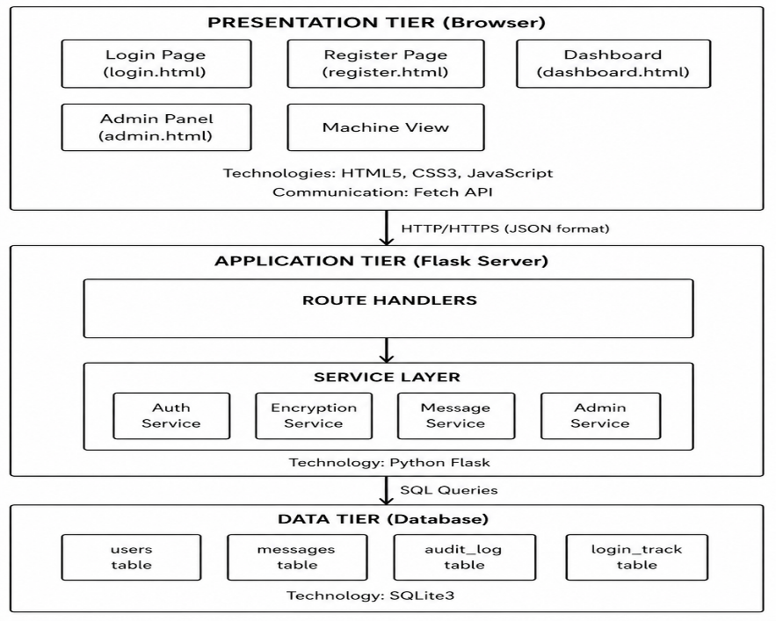
Tier Description Table:
Tier | Name | Technology | Responsibility
Tier 1 | Presentation | HTML, CSS, JavaScript | User interface, form inputs, displaying results, sending API requests
Tier 2 | Application | Python Flask | Business logic, encryption/decryption, request handling, session management
Tier 3 | Data | SQLite3 | Storing users, messages, audit logs, login tracking

2.2 Module Interaction Flow
This diagram shows how different modules within the system communicate with each other during various operations.
Module Interaction Diagram:
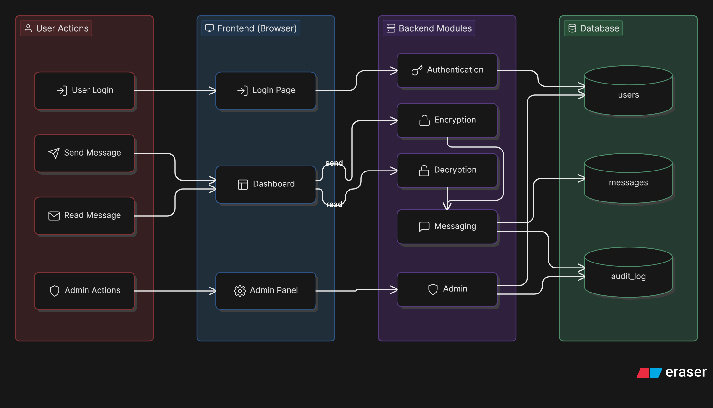
Interaction Flow Explanation Table:
User Action | Frontend Page | Backend Module | Database Table | Description
Login | login.html | Authentication Module | users | Verifies credentials and creates session
Send Message | dashboard.html | Encryption + Messaging | messages, audit_log | Encrypts message and stores it
Read Message | dashboard.html | Decryption + Messaging | messages | Decrypts and displays message
Admin Approval | admin.html | Admin Module | users, audit_log | Approves or rejects pending users

3. Module Design
3.1 Module Overview
The system is divided into five core modules. Each module has a specific responsibility and works independently while communicating with other modules when needed. This modular design makes the system easy to develop, test, and maintain.
Module Overview Diagram:
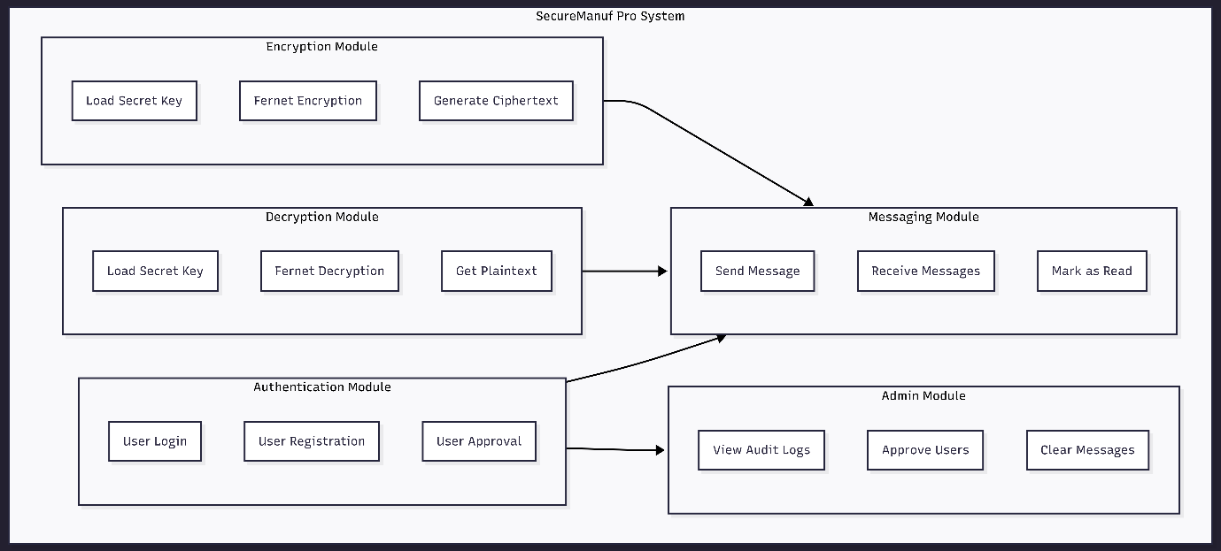

3.2 Authentication Module
This module manages user identity verification and access control. When a user logs in, the module checks the username against the database, verifies the password using hash comparison, confirms the account status is approved, and creates a session if all checks pass. For registration, the module validates that passwords match, ensures username uniqueness, hashes the password, and stores the user with pending status. For approval, the admin can change a user's status from pending to approved or rejected, and the action is logged in the audit trail

3.3 Encryption Module
The Encryption Module is responsible for converting readable plaintext into unreadable ciphertext. This ensures that even if someone accesses the database, they cannot read the actual message content. The module uses the Fernet symmetric encryption algorithm which guarantees that only someone with the correct secret key can decrypt the message.
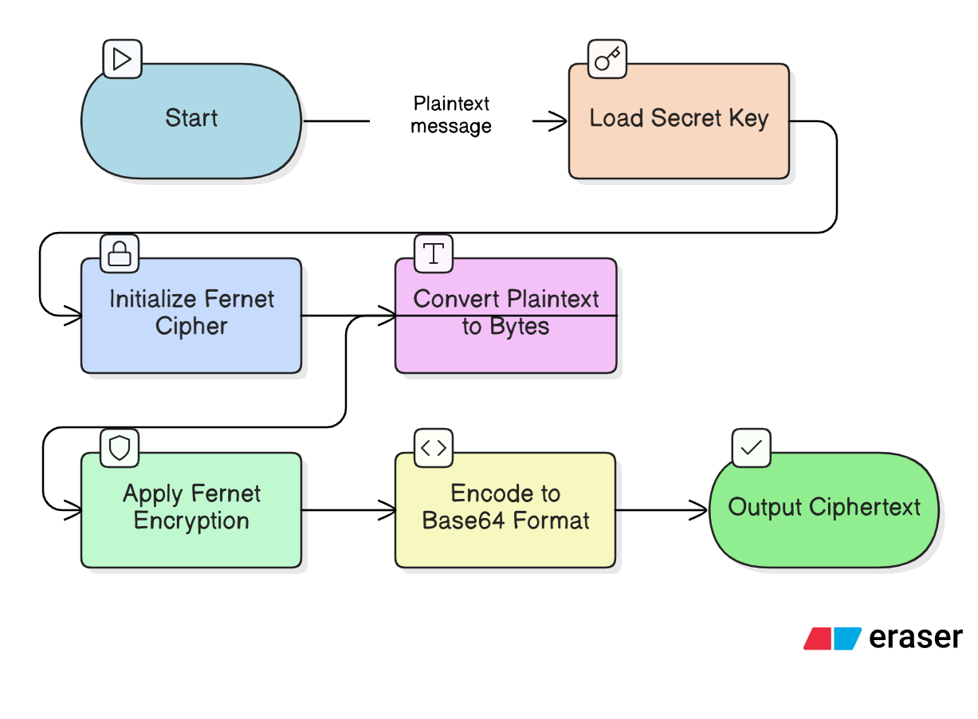
Process Steps | 1. Load the secret key from key.key file  2. Initialize Fernet cipher with the loaded key  3. Convert the plaintext string to bytes  4. Encrypt the bytes using Fernet  5. Encode the encrypted bytes to Base64 format  6. Return the ciphertext as a string

3.4 Decryption Module
The Decryption Module is responsible for converting ciphertext back into original plaintext. This module includes an authorization check to ensure that only the sender or the intended receiver can decrypt and read the message.

Decryption Module Diagram:
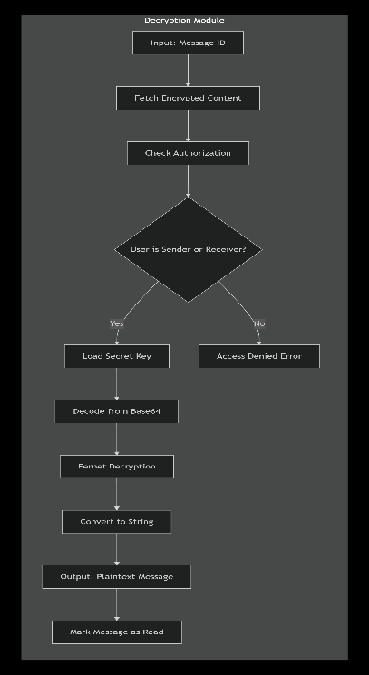
Process Steps | 1. Fetch the encrypted message from messages table by ID  2. Check if current user is sender or receiver  3. If not authorized, return access denied error  4. Load the secret key from key.key file  5. Decode the ciphertext from Base64 format  6. Decrypt the bytes using Fernet  7. Convert decrypted bytes back to string  8. Mark the message as read in database  9. Return the plaintext message

3.5 Messaging Module
The Messaging Module handles all operations related to sending and receiving messages. It works closely with the Encryption and Decryption modules to ensure messages are stored securely and delivered only to authorized users

4. Database Design
4.1 Database Schema
The database consists of four tables that store all system data. The tables are designed to be simple yet complete, with proper relationships and constraints to maintain data integrity.
Entity Relationship (ER) Diagram:
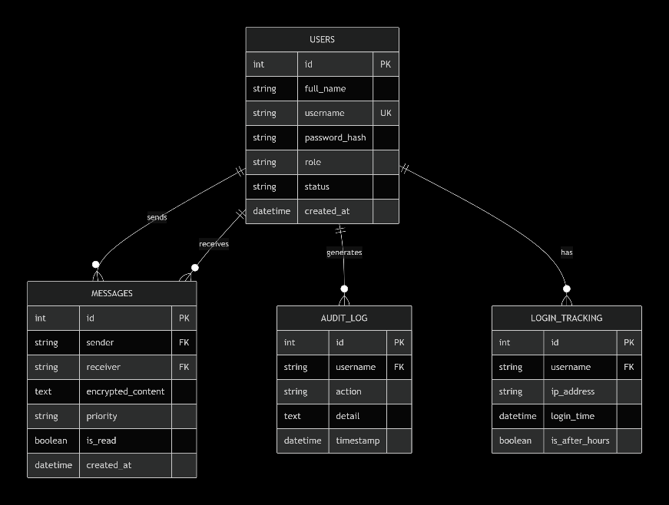
4.2 Table Structures
Table 1: users
This table stores all user account information including credentials and role.
Column | Data Type | Constraints | Description
id | INTEGER | PRIMARY KEY, AUTO_INCREMENT | Unique identification number for each user
full_name | TEXT | NOT NULL | Complete name of the user
username | TEXT | NOT NULL, UNIQUE | Login username, must be unique across all users
password_hash | TEXT | NOT NULL | SHA-256 hashed password, never stored as plaintext
role | TEXT | NOT NULL | User role: admin, operator, qc, or maintenance
status | TEXT | DEFAULT 'pending' | Account status: pending, approved, or rejected
created_at | DATETIME | DEFAULT CURRENT_TIMESTAMP | Date and time when account was created

Table 2: messages
This table stores all encrypted messages sent between users.
Column | Data Type | Constraints | Description
id | INTEGER | PRIMARY KEY, AUTO_INCREMENT | Unique identification number for each message
sender | TEXT | NOT NULL | Username of the person who sent the message
receiver | TEXT | NOT NULL | Username of the person who should receive the message
encrypted_content | TEXT | NOT NULL | The message encrypted using Fernet, stored as Base64 text
priority | TEXT | DEFAULT 'normal' | Urgency level: critical, high, normal, or low
is_read | BOOLEAN | DEFAULT 0 | 0 means unread, 1 means read by receiver
created_at | DATETIME | DEFAULT CURRENT_TIMESTAMP | Date and time when message was sent

Table 3: audit_log
This table tracks all important actions performed by users for security and debugging.
Column | Data Type | Constraints | Description
id | INTEGER | PRIMARY KEY, AUTO_INCREMENT | Unique identification number for each log entry
username | TEXT | NOT NULL | Username of the user who performed the action
action | TEXT | NOT NULL | Type of action: LOGIN, LOGOUT, SEND, DECRYPT, APPROVE, etc.
detail | TEXT |  | Additional information about the action (optional)
timestamp | DATETIME | DEFAULT CURRENT_TIMESTAMP | Date and time when action occurred

4.3 Relationships
Definition:
In a database system, relationships define how different tables are connected to each other. They help maintain data integrity and enable efficient data retrieval. Relationships are usually established using primary keys and foreign keys. Common types include one-to-one, one-to-many, and many-to-many relationships. In this system, relationships ensure proper linkage between users, messages, and tracking records while preserving important data for auditing and security purposes.

Relationship Table:
Relationship | Type | Description | Rules
users to messages (sender) | One-to-Many | One user can send many messages | When user is deleted, messages remain (for audit)
users to messages (receiver) | One-to-Many | One user can receive many messages | When user is deleted, messages remain (for audit)
users to audit_log | One-to-Many | One user can have many audit log entries | When user is deleted, logs remain (cannot be deleted)
users to login_tracking | One-to-Many | One user can have many login records | When user is deleted, login records remain

5. API Design
API (Application Programming Interface) is used for communication between frontend and backend using HTTP requests and JSON responses.

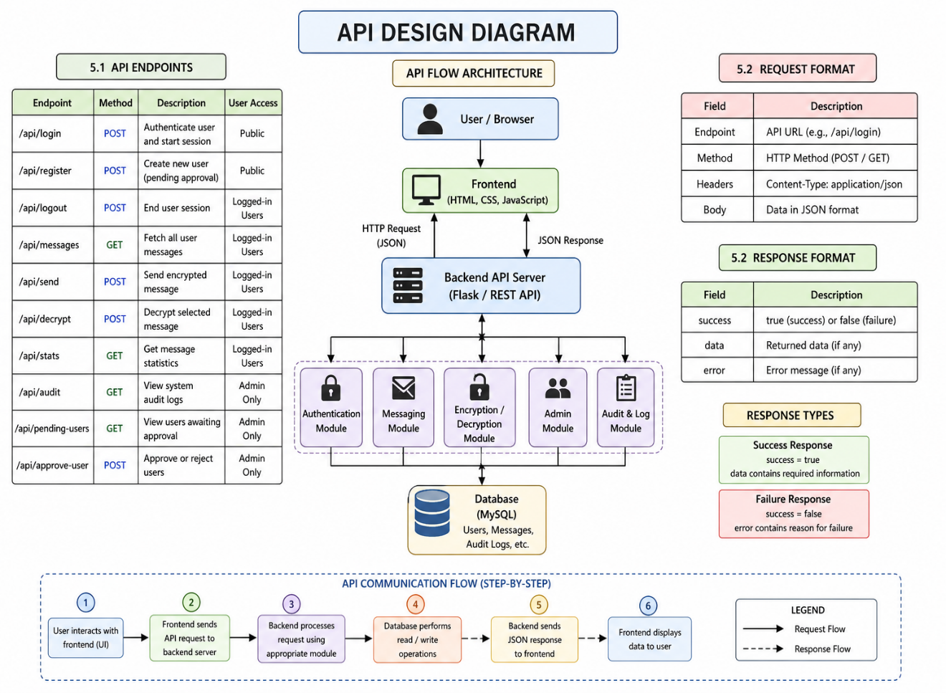
5.1 API Endpoints
Important API Endpoints Table
Endpoint | Method | Description | User Access
/api/login | POST | Authenticate user and start session | Public
/api/register | POST | Create new user (pending approval) | Public
/api/logout | POST | End user session | Logged-in Users
/api/messages | GET | Fetch all user messages | Logged-in Users
/api/send | POST | Send encrypted message | Logged-in Users
/api/decrypt | POST | Decrypt selected message | Logged-in Users
/api/stats | GET | Get message statistics | Logged-in Users
/api/audit | GET | View system audit logs | Admin Only
/api/pending-users | GET | View users awaiting approval | Admin Only
/api/approve-user | POST | Approve or reject users | Admin Only

Endpoint Classification
Category | APIs Included
Authentication | Login, Register, Logout
Messaging | Send, Messages, Decrypt
Dashboard | Stats
Admin Control | Audit, Pending Users, Approve User

5.2 Request and Response Format
Request Format Table
Field | Description | Example
Endpoint | API URL | /api/login
Method | HTTP method | POST / GET
Headers | Metadata (Content-Type) | application/json
Body | Data sent to server | Username, Password

Response Format Table
Field | Description | Example
success | Indicates operation result | true / false
data | Returned information | User details / messages
error | Error message (if failed) | Invalid credentials

6. Process Flow
What is Process Flow?
Process flow is the sequence of steps that happen from the moment a user starts an action until the action is completed. It shows how data moves from one component to another and what happens at each stage. In this system, the main process flow covers three key actions: logging into the system, sending an encrypted message, and decrypting and reading that message.
6.1 System Workflow (Login → Encrypt → Decrypt)
Overall Flow Diagram:
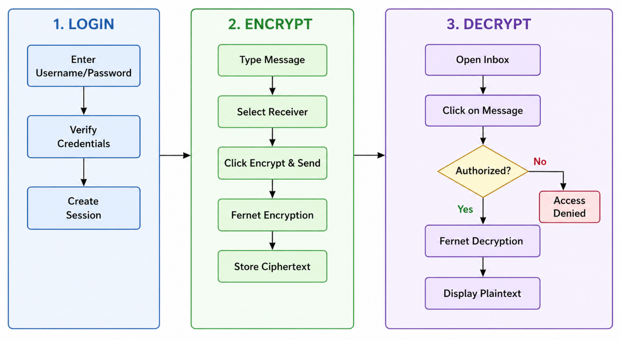
1. Login Process
Login is the process of verifying a user's identity before allowing access to the system. The user enters their username and password. The system checks if the username exists in the database, then verifies if the password matches the stored hash. It also checks whether an admin has approved the account. If all checks pass, the system creates a session for the user and redirects them to the dashboard. If any check fails, an error message is shown. Every login attempt is recorded in the login tracking table for security.

2. Encrypt Message Process
Encrypt message is the process of converting a readable plaintext message into unreadable ciphertext before storing it. The user types a message, selects a receiver, and chooses a priority level. When they click send, the system loads the secret key, initializes the Fernet cipher, converts the plaintext to bytes, encrypts it, and encodes the result to Base64. Only this encrypted ciphertext is stored in the database. The original plaintext message is never saved anywhere, ensuring that even if someone accesses the database, they cannot read the actual message.

3. Decrypt Message Process
Decrypt message is the process of converting the stored ciphertext back into readable plaintext for authorized users. The receiver opens their inbox and clicks on a message. The system first checks if the user is authorized, meaning they must be either the sender or the intended receiver. If authorized, the system loads the same secret key, decodes the ciphertext from Base64, decrypts it using Fernet, and converts the bytes back to a string. The original message is then displayed on screen and automatically marked as read. If an unauthorized user tries to open the message, an "Access Denied" error is shown.

7. Session and Access Control
7.1 Session Handling
Session handling is the method used to keep a user logged in while using the application. In SecureManuf Pro, once a user logs in with valid and approved credentials, the server creates a session that stores details like username and role. A session cookie is sent to the browser, and it is used in every request so the user can access the dashboard, send messages, and view the inbox without logging in again. The session is stored on the server and automatically ends when the user logs out, closes the browser, or stays inactive for 30 minutes.
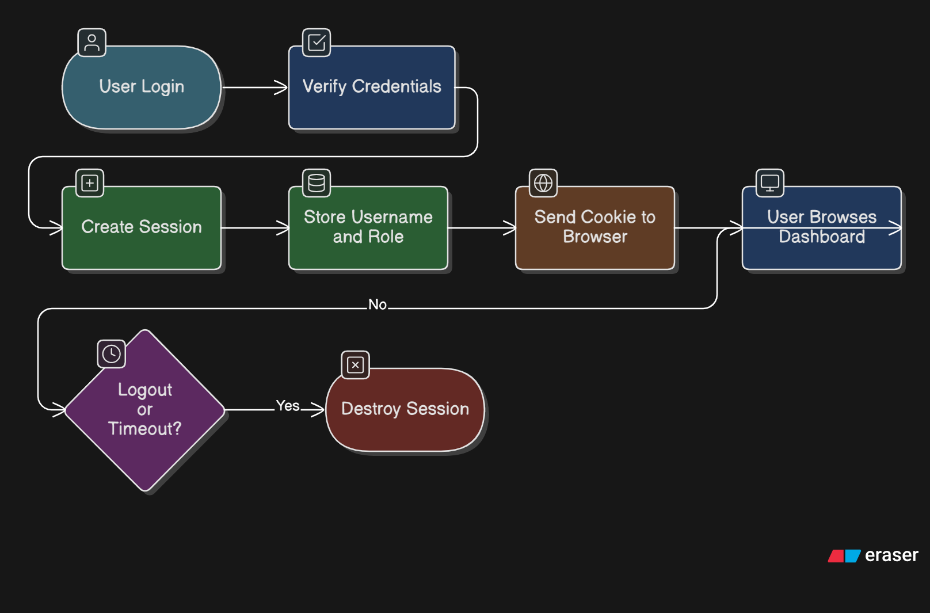

7.2 Role-Based Access Control
Definition:
Role-Based Access Control (RBAC) is a security approach where users are assigned specific roles, and each role has defined permissions. Instead of giving permissions directly to individual users, permissions are given to roles, and users inherit permissions from their assigned role. This makes it easy to manage access for many users. In this system, there are four roles: Admin, Operator, QC Inspector, and Maintenance. The Admin role has full access including approving users and viewing audit logs. Other roles have limited access based on their job function. When a user tries to perform any action, the system checks their role from the session and allows or denies access accordingly

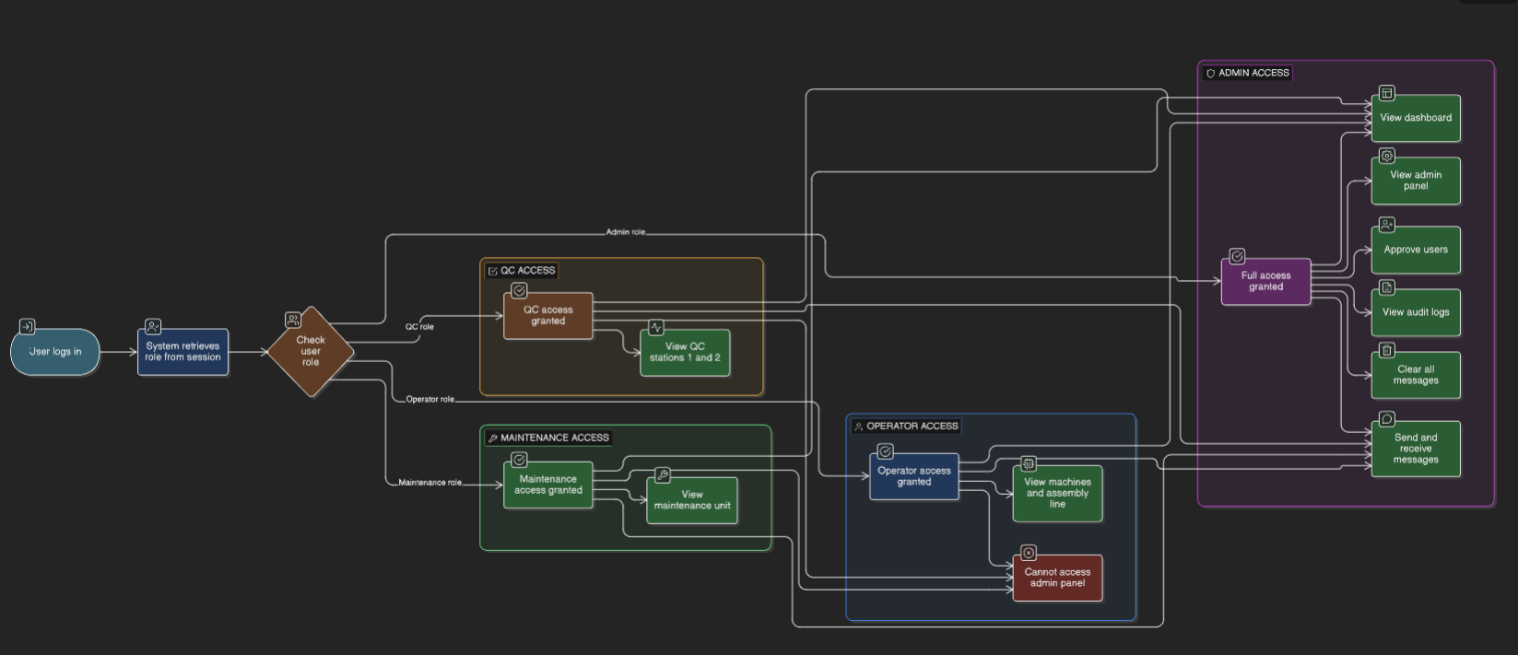

8. Error Handling and Validation
8.1 Error Handling
Definition: Error handling is the process of detecting when something goes wrong in the application and showing a helpful message to the user with the appropriate HTTP status code. In SecureManuf Pro, errors are displayed as toast notifications at the bottom right corner of the screen for 3 seconds.
Error Codes and Messages Table:
Error Code | HTTP Status | Message | When It Happens
AUTH-001 | 401 Unauthorized | Invalid username or password | User enters wrong login credentials
AUTH-002 | 403 Forbidden | Account pending approval | New user tries to login before admin approval
AUTH-003 | 401 Unauthorized | Session expired, please login again | User inactive for more than 30 minutes
AUTH-004 | 400 Bad Request | Username already exists | User tries to register with taken username
AUTH-005 | 400 Bad Request | Passwords do not match | Password and confirm password fields don't match
MSG-001 | 404 Not Found | Message not found | User tries to open a message that doesn't exist
MSG-002 | 403 Forbidden | Access denied | User tries to decrypt message not meant for them
MSG-003 | 400 Bad Request | Message cannot be empty | User tries to send a blank message
ADM-001 | 403 Forbidden | Admin access required | Non-admin user tries to access admin panel
SUCCESS | 200 OK | Action completed successfully | Login, send, decrypt, or any action works fine

8.2 Validation Rules
Definition: Validation rules are checks performed on user input before processing it to ensure the data meets required standards.

Validation Rules Table:
Field | Rule | HTTP Status | Error Message
Username | Minimum 3 characters, letters and numbers only | 400 | Username must be at least 3 characters
Password | Minimum 4 characters | 400 | Password must be at least 4 characters
Full Name | Cannot be empty | 400 | Full name is required
Message | Cannot be empty, Maximum 5000 characters | 400 | Message cannot be empty
Confirm Password | Must exactly match Password field | 400 | Passwords do not match

9. References
Reference | Source URL | Used For
Python Official Documentation | https://docs.python.org/3/ | Python programming language syntax and functions
Flask Framework Documentation | https://flask.palletsprojects.com/ | Web framework for backend development
Cryptography (Fernet) Documentation | https://cryptography.io/en/latest/fernet/ | Encryption and decryption implementation
SQLite3 Documentation | https://sqlite.org/docs.html | Database design and SQL queries
HTML5 and CSS3 Documentation | https://developer.mozilla.org/ | Frontend user interface development
JavaScript Documentation | https://developer.mozilla.org/en-US/docs/Web/JavaScript | Client-side form validation and API calls
Mermaid.js Documentation | https://mermaid.js.org/ | Creating flowcharts and diagrams
OWASP Authentication Cheat Sheet | https://cheatsheetseries.owasp.org/ | Session management and security guidelines

